|  |  |
| --- | --- |
| **1** | **INTRODUCTION** |
|  | **1.1 OVERVIEW** |
|  | **1.2 PURPOSE** |
| **2** | **PROBLEM DEFINITION AND DESIGN THINKING** |
|  | **2.1 EMPATHY MAP** |
|  | **2.2 IDEATION & BRAINSTROMING MAP** |
| **3** | **RESULT** |
| **4** | **ADVANTAGES & DISADVANTAGES** |
| **5** | **APPLICATIONS** |
| **6** | **CONCLUSION** |
| **7** | **FUTURE SCOPE** |

1. **INTRODUCTION**
   1. **OVERVIEW**

A basic overview of what such a project might entail. The project goal is to analyze , rank Or simply discover the top YouTube channels across various categories. Gather data on YouTube channels and to collect information such as subscriber counts, view counts and categories.

Group the channels into categories like music, education etc., to make the analysis more manageable. Import the data into Tableau . Create various visualizations to explore the data. Some useful visualizations might include bar charts for top channels by subscribers, line charts for channel growth over time and visualize the distribution of top channels around the world. Build interactive dashboards in tableau. These dashboards can include filters and actions to allow users to explore the data in a dynamic way. We can use Tableau Desktop for this purpose.

* 1. **PURPOSE**

Analyzing data on top YouTube channels to identify trends in terms of content, subscribers and views. Categorizing and visualizing the types of content that perform well on YouTube. Examining where these top channels are based and identifying regional differences.Thes visualizations can provide insights for content creators, marketers and researchers interested in the YouTube platform.

|  |  |
| --- | --- |
|  | **2 PROBLEM DEFINITION AND DESIGN THINKING** |
|  | **2.1 EMPATHY MAP** |

2.2 IDEATION & BRAINSTROMING MAP

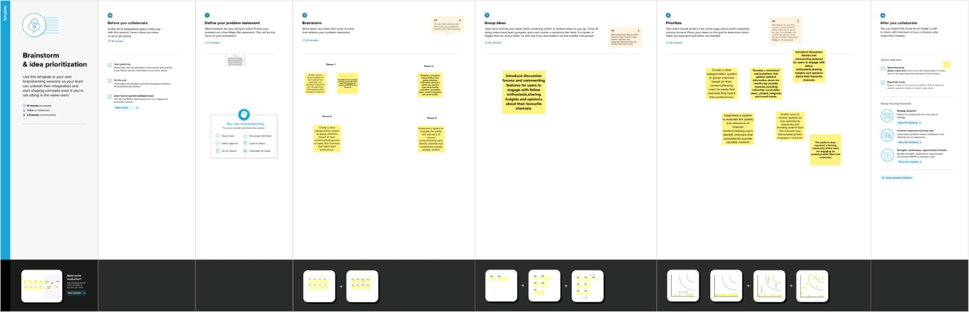

**3 RESULT**

Create various visualizations in Tableau to explore the data. To create bar charts to show the top channels by subscribers, pie charts to depict the distribution of content categories. Combine different visualizations into a dashboard and use Tableu’s storytelling feature to create a narrative around the data. Explain about key insights, trends and any interesting findings.

**4 ADVANTAGES & DISADVANTAGES**

**ADVANTAGES:**

* Tableau is excellent for visualizing data, making it easier to spot trends and patterns among top YouTube channels.
* To create interactive dashboards to allow users to explore the data and gain insights.
* Tableau allows for customization of charts and graphs to fit your specific analysis needs.

**DISADVANTAGES:**

* Tableau can be expensive and its pricing model may not be suitable for all budgets.

**5 APPLICATIONS:**

* Analyze the data to identify trends, patterns and insights about the top YouTube channels.
* Create a visualization that ranks the top YouTube channels based on subscribers, view or engagement metrics.
* To visualize the geographic distribution of these top channels and their audience
* Analyze the content of videos using natural language processing techniques to understand what topics or categories are popular among top channels.

**6 CONCLUSION:**

In the TABLEAU project exploring the world’s top YouTube channels, we found valuable insights about the factors contributing to their success. We identified trends in content types , categories and audience demographics. This analysis can inform content creators and marketers to optimize their strategies for YouTube success.

**7 FUTURE SCOPE:**

The future scope of such a project lies in its ability to adapt to evolving YouTube trends and technologies, enabling content creators and marketers to stay ahead of the curve in the dynamic world of online video. As YouTube continues to grow and change, the insights derived from Tableau analysis can inform strategies for sustained success.